Homework #1
Problem 1
Script
clear all
clc
close all
format compact

% Use 1/2 inch increments for calculating the deflections
x = 0:0.5:360;
% Calculate the defelction
for i=1:length(x)
y(i)=(800*x(i)^3 - 13.68*10^6*x(i) - 2.5*x(i)^4 +2.5*(x(i)-120)^4*(x(i)>=120) +600*(x(i)-240)^3*(x(i)>=240))/(3.190*10^9);
end

[max_y, max_x]=max(abs(y));

% Plot
hold on
plot(x,y,'Linewidth',2 );
plot(x(max_x),y(max_x),'o','MarkerSize',8,'MarkerEdgeColor','k','MarkerFaceColor','r')
text(x(max_x)*1.05,y(max_x)*1.05, ['(',num2str(x(max_x)),',',num2str(y(max_x)),')'])
xlabel('inch', 'FontSize', 18);
ylabel('defelction', 'FontSize', 18);
hold off

Graph
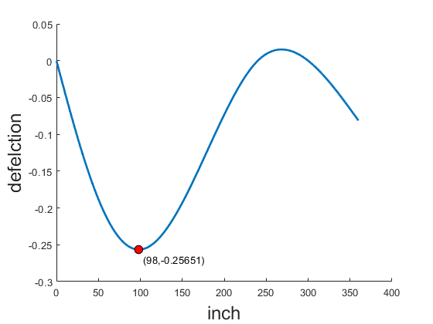

Problem 2
Script
clear all
close all
clc
format compact

% 1.Enter data from file Points.txt to Matlab workspace
MyFile = fopen ('Points.txt','rt');
A=textscan(MyFile,'%f %f','HeaderLines',1);
A=cell2mat(A);
fclose(MyFile);

x=A(:,1);
y=A(:,2);

% 2.Draw the polygon;
figure;
hold on
plot([x;x] ,[y;y],'Color','r','Linewidth',2,'DisplayName','Polygon')

% 3.Calculate the area of the polygon, print the answer to the Command Window;
area = area_of_the_polygon(x,y);
fprintf('the area of the polygon %g\n',area);

% 4.Calculate the coordinates of the centroid of the polygon,print the answer to the Command Window
[coordinates_x,coordinates_y] = coordinates_of_the_centroid(x,y,area);
fprintf('the coordinates of the centroid of the polygon (%g,%g)\n',coordinates_x,coordinates_y);

% 2.Draw the coordinates;
plot(coordinates_x ,coordinates_y ,'o','MarkerSize',8,'MarkerEdgeColor','k','MarkerFaceColor','g','DisplayName','Center')
plot(x ,y ,'o','MarkerSize',8,'MarkerEdgeColor','k','MarkerFaceColor','r','DisplayName','Point')
legend ('Fontsize',12,'FontWeight','bold')
hold off

function area = area_of_the_polygon(x,y)
n=length(x);
area = 0;
for i = 1:n-1
area = area + 1/2 *(x(i) * y(i+1)-x(i+1) * y(i));
end
end

function [coordinates_x,coordinates_y] = coordinates_of_the_centroid(x,y,area)
n=length(x);
coordinates_x = 0;
coordinates_y = 0;
for i = 1:n-1
coordinates_x = coordinates_x +(x(i)+x(i+1) )* (x(i) * y(i+1)-x(i+1) * y(i))/6/area;
coordinates_y = coordinates_y + (y(i)+y(i+1))* (x(i) * y(i+1)-x(i+1) * y(i))/6/area;
end
end

Result
the area of the polygon 29.575
the coordinates of the centroid of the polygon (1.15054,3.07711)

Graph
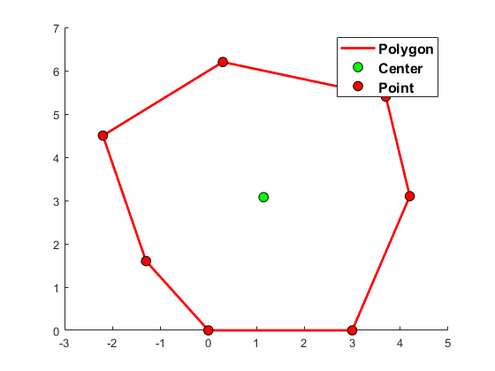

Problem 3
Script
clear all
close all
clc

% Create File
fid = fopen('Problem3_Result.txt', 'wt');
payment=1199.11;

% Calculate Balance
Balance_End =repmat(200000,1, 360);
Balance_Begin=repmat(0, 1, 360);
Balance_Begin(1)=Balance_End(1)*1.005;
Balance_End(1)= Balance_Begin(1)-payment;
for month = 2:360
Balance_Begin(month)=Balance_End(month-1)*1.005;
Balance_End(month)=Balance_Begin(month)-payment;
end
% Write File
fprintf (fid,' Beginning Ending \n');
fprintf (fid,'Month Balence Payment Balance \n');
fprintf (fid,'===== ========= ======= ======= \n');
for month = 1:360
if month<=12
fprintf (fid,'%5i %-9.2f%8.2f%10.2f\n',month,Balance_Begin(month),payment,Balance_End(month));
end
if month==359
fprintf (fid,'\n\n\n');
end
if month>=359
fprintf (fid,'%5i %-9.2f%8.2f%10.2f\n',month,Balance_Begin(month),payment,Balance_End(month));
end
end
fprintf(fid,'\nFinal balance to be refunded = %.2f\n',Balance_End(month));
fclose(fid);

Result
Beginning Ending
Month Balence Payment Balance
===== ========= ======= =======
1 201000.00 1199.11 199800.89
2 200799.89 1199.11 199600.78
3 200598.79 1199.11 199399.68
4 200396.68 1199.11 199197.57
5 200193.55 1199.11 198994.44
6 199989.42 1199.11 198790.31
7 199784.26 1199.11 198585.15
8 199578.07 1199.11 198378.96
9 199370.86 1199.11 198171.75
10 199162.61 1199.11 197963.50
11 198953.32 1199.11 197754.21
12 198742.98 1199.11 197543.87

359 2383.31 1199.11 1184.20
360 1190.12 1199.11 -8.99

Final balance to be refunded = -8.99

